We have selected a part from Abundant Life lesson 1.
On the right are seven tips for a succesful microlearning snippet. For this task focus on the tips 1,3,5,6)!

Task 1: Discuss:
What is the learning objective in this part of the lesson?

Which task do you want to do together? Task 2 or task 3?

Task 2
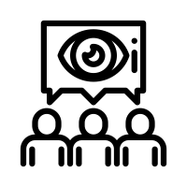
Come up with one visual to add to this lesson. It can be:
- An illustration;
- A picture;
- An infographic;
- Something else.

- Draw or describe what you would create on your big sheet of paper.
- Or make an actual picture with the people and props available in the room.

Task 3
Choose one of the following to enhance this lesson part:
- A Video or Podcast
- An Interactive Activity;
- A Poll / Discussion Question / Social Media Post for students.

- For the podcast or video describe:
- The information in the video or podcast
- Who would be the speaker(s). Why?
- How long it is.
- What the benefit to the learner is.
- How it fits in the lesson objective.
- For the activity or social post describe:
- What students need to do.
- How long it takes them to do.
- What the benefit to the learner is.
- How it fits in the lesson objective.

- If you feel very creative record a video or podcast in the room!

