Exploring New Horizons Conference
We had a remarkable time together in our Kuala Lumpur conference on 20 - 25 April 2015! Here’s what participants said about it:
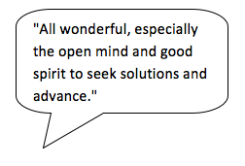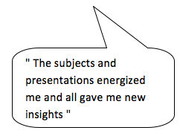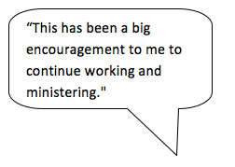

Who organised it?
The conference was run by Increase. It was founded in 2006 to increase access to training outside the traditional residential systems, and to foster good quality equipping.
We are passionate to see:
churches equipping all Christ’s followers in their contexts,
so that many millions are discipled and empowered
for mission, ministry and leadership.
Increase works to connect and strengthen church-based training programs in Asia and beyond. Currently most of them use a method called TEE, which stands for Theological Education by Extension but is more easily explained as ‘Tools to Equip and Empower’. This training approach gives tools for local churches to equip and empower all believers to serve Christ actively in their contexts. Around 100,000 believers in Asia study every year in this way.

Who came to the conference?
Participants came by invitation. They were national directors of church-based training programs from every corner of Asia, along with others active in Increase, and selected representatives from other continents. We were at full capacity!

What were the conference aims?
1. To explore ‘new horizons’ in church-based training today;
2. To forge a new structure for Increase;
3. To introduce Increase to Malaysian church leaders.
Were these aims achieved? Yes, very much so! Here’s how…

1. Exploring ‘new horizons’
Beforehand we asked practitioners in Asia about key challenges for church-based equipping, and new horizons in the 21st century. Their suggestions generated our agenda:
Training for transformation:
➢ to obey Christ and become like him,
is our overarching goal and the springboard for any fresh activity (*)
The ‘new horizons’ of:
➢ new courses for contemporary Asia (*)
➢ ministry with diaspora churches in multicultural contexts (*)
➢ the digital age
➢ experiential learning and brain research
➢ oral preference learners
The challenges of:
➢ serving churches spread across huge areas
➢ growing stronger partnerships with local churches
➢ training and supporting local learning group leaders(*)
➢ building support relationships for sustainable ministry
For each topic, the learning was team-led and highly interactive, with active learning tasks. The four topics marked (*) above will be taken forward by ‘task groups’ in much greater depth over the coming months. Increase aims to make an Asian contribution to global discussion on these topics and to create training resources for practical improvement in these areas.

2. Forging a new structure
Increase had functioned as a relational network for its first nine years, but by 2015 it needed a stronger (though still relational!) structure to take up the tasks and to ensure Asian ownership. So the conference launched Increase as an Association whose core members are church-based programmes owned and governed in Asia. Organisations outside the region may join as fellowship members, with the other categories being individual members and friends of Increase.
The serving base for Increase will be in Kuala Lumpur and the Association members are expected to share fruitful practice, provide support and training, catalyze innovative approaches and make a global contribution to theological education and adult learning. The conference elected a committee of experienced practitioners to give oversight to Increase’s work; the chairperson is Mr. Zafar Ismail. We also expressed great gratitude to the outgoing chairperson Mr. Richard Morris who had led Increase so wisely for the previous six years.

3. ‘Discipling the Nations’ dinner
At this memorable event, the conference participants mingled with more than 60 Malaysian church leaders (pastors and those ministering amongst migrant workers). The atmosphere was very special from the start, as the greeting ‘Welcome in the Name of Jesus Christ!’ rang out in more than 20 languages.
Over dinner, conversation flowed in table groups of compatible people, such as one table which brought together Nepali leaders with Malaysians working among migrant Nepalis.
After the meal, there was a wonderful programme with inspiring testimonies of changed lives through church-based TEE in China, Pakistan, Central Asia, Nepal and Malaysia itself. The occasion certainly raised the profile of Increase and has already spouted plans to start TEE groups locally in Nepali, Urdu, Tamil and English. The course books are already available in all these languages. We now need to help local churches connect with the national training programmes in order to obtain the materials, equip group leaders and ensure the learning groups run well.
‘Discipling the Nations’ – both there (across Asia) and here (in Malaysia) - an exciting vision!

